**EX No: 3a                                                       Date: 22.02.2025**

**NAME:SSubramanian**

**ROLLNO:230701349**

**Create a prototype with familiar and unfamiliar navigation elements. Evaluate ease of use with different user groups using proto.io**

**AIM:**

The aim is to develop a prototype incorporating both familiar and novel navigation elements and assess usability among diverse user groups using Proto.io.

**PROCEDURE:**

**i) Example 1:**

**Tool Link:** [**https://proto.io/**](https://proto.io/)

**Step 1: Sign Up and Log In**

1. Go to proto.io.
2. Sign up for a new account or log in if you already have one.

**Step 2: Create a New Project**

1. Click on "Create New Project."
2. Give your project a name (e.g., " App ").
3. Select the device type (e.g., Mobile - iPhone X).
4. Click "Create" to start the project.

**Step 3: Design the Home Screen**

1. Add a New Screen:
   * Click on the "+" button in the left panel to add a new screen.
   * Choose "Blank" and name it "Home."
2. Add Elements to the Home Screen:

* Drag a "Header" widget from the "Widgets" panel to the top of the screen.
* Double-click the header to edit the text and change it to "Home Screen."
  + Drag a "Button" widget onto the screen. Place it in the center.
  + Double-click the button to edit the text and change it to "Go to Profile."

3.Add Interaction:

* + Select the button and click on the "Interactions" tab on the right panel.
  + Click "+ Add Interaction."
  + Set the trigger to "Tap/Click."
  + Set the action to "Navigate to Screen" and choose "New Screen."
  + Create a new screen and name it "Profile."

**Step 4: Design the Profile Screen**

1. Add Elements to the Profile Screen:
   * On the newly created Profile screen, drag a "Header" widget to the top of the screen.
   * Double-click the header to edit the text and change it to "Profile Screen."
   * Drag an "Image" widget onto the screen. Place it below the header.
   * Double-click the image to upload a profile picture or any placeholder image.
   * Drag a "Text" widget onto the screen to add some profile information (e.g., "John Doe, Software Engineer").
2. Add Back Button:
   * Drag a "Button" widget onto the screen.
   * Double-click the button to edit the text and change it to "Back to Home."
3. Add Interaction:
   * Select the button and click on the "Interactions" tab on the right panel.
   * Click "+ Add Interaction."
   * Set the trigger to "Tap/Click."
   * Set the action to "Navigate to Screen" and choose "Home."

**Step 5: Preview the Prototype**

1. Click on the "Preview" button in the top-right corner.
2. Interact with the prototype by clicking on the buttons to navigate between the Home and Profile screens.

**Step 6: Share the Prototype**

1. Click on the "Share" button in the top-right corner.
2. Copy the shareable link and send it to others for feedback.

**OUTPUT:**

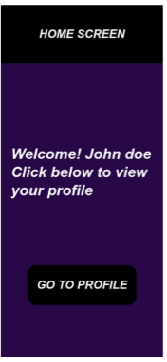  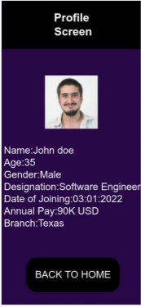

**RESULT:**

Creating a prototype with familiar and unfamiliar navigation elements using proto.io

has been executed successfully.